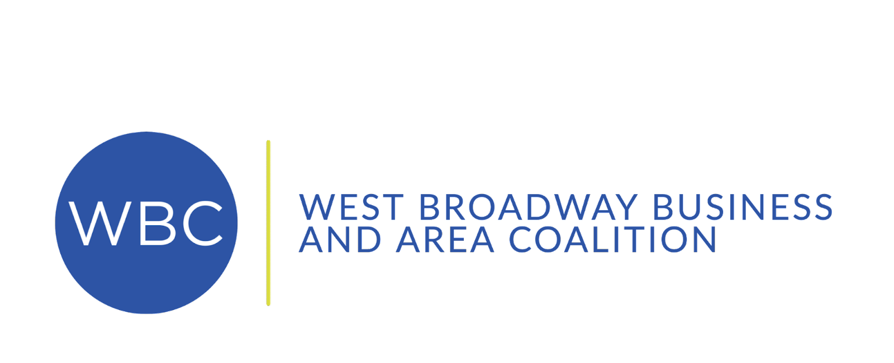

Executive Director

Position Description

CONTACT INFORMATION
Strategic Consulting & Coaching
www.strategic-cc.com
Cheryl Jensen
612-203-4662
cjensen@strategic-cc.com

ORGANIZATIONAL OVERVIEW
Since 2007, the West Broadway Business and Area Coalition (WBC) has been building the capacity of businesses and entrepreneurs, highlighting the positive business and cultural assets of North Minneapolis, and engaging the resident and business community in the transformation of the West Broadway commercial corridor. WBC curates community-identified activities designed to transform West Broadway into a thriving commercial corridor that meets the goods, service, and entertainment needs of neighborhood residents, businesses, and visitors.
The WBC is a membership-based organization that collaborates with and advocates for its members representing small businesses, social enterprises, artists, farmers market vendors, and nonprofits. It is governed by an engaged, culturally diverse Board of Directors.
OUR MISSION │To create an inviting and vital West Broadway Corridor and to transform the Northside into a thriving economic community.

PROGRAM OVERVIEW
The WBC’s core programs and initiatives fall under the following categories:
District-wide Improvements
- West Broadway District Arts Initiative
- Facade Improvement Program
- Business Recruitment
Entrepreneur Opportunities
- Flea, Artist, and Holiday Markets and Pop-up Boutiques
- Calls for Artists: placemaking, public art, and engagement
- Related Technical Assistance
Advocacy and Communications
- Showcase Events: FLOW Northside Arts Crawl and Open Streets
- Media Relations and Storytelling
- Business Committee Networking Events
- Resource Brokering
- Transit and Pedestrian Advocacy

POSITION OVERVIEW
The Executive Director (ED) represents an organization that stands for positive change through coalition building, cooperation between disparate stakeholders, innovative initiatives, and effective marketing of the area to a broader base. The ED should be passionate about working within this community.
In 2022, the Board of Directors and staff completed a strategic planning process. The ED is responsible for working with the Board and staff to oversee implementation of the strategic plan and accomplishing its goals and objectives. The ED oversees and implements the overall management of the organization. Within the parameters established by the Board of Directors, the ED hires/supervises staff, oversees fundraising and organizational development activities, builds productive connections within the community, engages with stakeholders, and represents the West Broadway Coalition in the broader community (and completes other duties as assigned by the Board of Directors).
The ED is responsible for overseeing the administration and implementation of economic development activities by providing structure and support to the organization’s program areas. It is the responsibility of the ED to work with Board and staff to draft an annual budget and to design and implement fundraising initiatives sufficient to meet that budget. The responsibility is to raise the budget sufficient to operate the organization, implement its programs, and deliver the desired outcomes.

PROFESSIONAL EXPERIENCE

The successful candidate will:
- Be a visionary leader with the ability to manage in a complex environment and interact effectively with a wide range of individuals.
- Be an enthusiastic and inspirational motivator of people and a strong relationship builder.
- Demonstrate their ability to promote and encourage staff and volunteer development, carry out effective team leadership, and exemplify a positive-outcomes performance attitude.
- Have strategic and innovative planning ability, critical thinking skills, significant time management skills, and the ability to implement long-term vision and annual objectives.
- Be successful at fundraising and securing contracts and have grant and/or proposal writing experience.
- Be knowledgeable about nonprofit management, laws, and rules.
- Have exceptional written and oral communication skills.
- Preferably have knowledge of commercial corridor revitalization strategies and best practices including business improvement districts, farmers markets, arts, creative place making, real estate, business associations, branding, etc.

EDUCATION

The successful candidate will:
- Have a master’s degree, MBA, or hold a bachelor’s or equivalent advanced degree in a related field.
- Have appropriate background in community and economic development, real estate, nonprofit development, for-profit industry, or work in government agencies.
- Have equivalent work experience in an appropriate discipline (e.g., education, social sciences, public administration, business administration).
- Have 3-5 years of management and leadership experience that includes coalition building and supervisor experience.

COMPENSATION & BENEFITS
The executive compensation package for this position is competitive and includes participation in the organization’s benefits plan.

COVER LETTER & RESUME

Please send cover letter and resume to:

Cheryl Jensen, M.S., PCC, RLC
Strategic Consulting & Coaching, Managing Partner
612-203-4662
cjensen@strategic-cc.com

